Leukaemia & Lymphoma NI
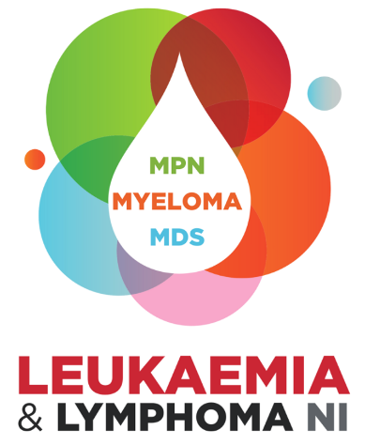

Travel Fund
Application Form

Aim of Travel Fund:
We want to enable diagnostic staff working in haematology laboratories to attend relevant conferences and events, to learn from colleagues in other parts of the UK and Ireland and make connections to enable shared learning and collaboration. We hope this will result in more skilled and knowledgeable diagnostic staff in Northern Ireland, improving the quality and ranges of diagnostic testing for patients with suspected blood cancer.
Eligibility Criteria:
- Applicants must be currently employed in a haematology diagnostic laboratory in Northern Ireland to apply.
- Applicants must seek a support from line manager/supervisor to attend the outlined conference prior to submitting the application.

Maximum Award:
£1000 with an expectation that travel and accommodation will be booked early in order to secure best value for money.
Guidance notes:
Question 2 – Please provide a breakdown of the individual costs and total amount requested. Please note receipts for all expenditure must be provided after the event.
Question 3 – Please include the title of the conference, organising organisation, date(s) attending and the location
Question 4 – Please use this section only to outline the relevance of the course to your current role and blood cancer diagnosis & treatment Max Word Count 100
Question 5 – Please outline what you hope to learn from the event, possible networking opportunities and the potential benefit to blood cancer patients. Max Word Count 150
Assessment process:
- All applications should be emailed to info@llni.co.uk and can be submitted at any time.
- Applications will be assessed internally and the relevance of the event checked with an independent clinical expert.
- Shortlisted applications will be considered at following full board meeting.
- Applicants should expect a decision within 8 weeks, so please ensure applications are submitted in sufficient time to allow attendance at the event.
- All applicants will be advised of the outcome of their application via email.
Please Note:
- All information supplied in this application is treated in confidence. The information is furnished to Leukaemia & Lymphoma NI with the understanding that it shall be used or disclosed for evaluation, reference and reporting purposes. If your application is not successful, this form will be destroyed after the retention period deemed as appropriate by the Scientific and Medical Advisory Panel.
- Applicants should be aware that if they receive LLNI funding and then fail to attend the stated event any funding received must be repaid to LLNI by the applicant.
- Successful applicants will be required to provide either a written report or deliver a presentation to the Leukaemia & Lymphoma NI Board of Directors.

LEUKAEMIA & LYMPHOMA NI
Application for Travel Fund

- Applicant

Name: | Title:
Contact Details:

Telephone: | Email:
Academic qualifications:

Current Position & Band:

Current Location:

Previous positions:

- Amount Requested:

- Details of Event/Conference:

- Details of why you are attending:

- Outcome of Event:

- Signatures:

- Applicant

I declare that the information provided is true and accurate. If the application is successful, I agree to abide by the Award Conditions of the Leukaemia & Lymphoma NI.

Signature: | Date:

- PI/Supervisors Name -

Signature: | Date:

