Leukaemia & Lymphoma NI
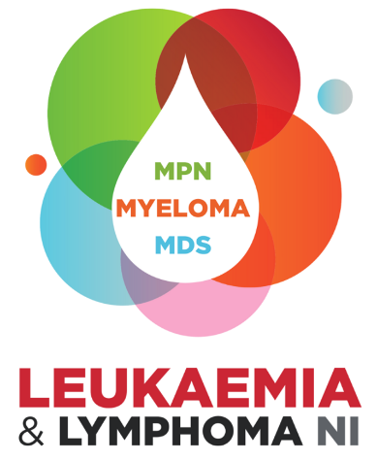

Project Fund 2026
Triage Application Form

Eligibility and Guidance
Aim of Project Fund:
This fund is designed to support research proposals to fund consumables, equipment and project staff or research time. We hope this investment will allow Principal Investigators to conduct further research into a key scientific discovery, to progress the research towards kinder, more effective treatments or understand more about the causes of blood cancers.
Eligibility Criteria:
- Applicants must be currently employed within an academic research institution or within a haematology diagnostic laboratory in Northern Ireland to apply.
- Applicants must be planning to seek funding for a research project which has the potential to have a positive impact on blood cancer patients in Northern Ireland.
Maximum Award:
£30,000-£75000, while it is not envisaged these awards will fund full time research staff, we will consider applications with staffing resources alongside other project costs. Proposals for part funding will be considered, as long as match funding has already been secured.
Guidance notes:
Question 2 – Please describe the early results from previous research that has led to the development of the project proposal Max word count 500
Question 3 – Outline the concept, purpose and aims of the proposal, making reference to why this proposal will build on previous scientific discovery Max word count 500
Question 4 – Please detail the expected outcomes or learning expected as a result of the funding
Max word count 500
Question 5 – Please provide a short layman’s explanation about the proposal and how it has the potential to make progress towards kinder, more effective treatments Max word count 500

Question 6 – Please provide a breakdown of the costs involved in the project delivery, including any relevant comments or justifications for the amounts/items requested.
Assessment process:
- All completed triage applications should be emailed to info@llni.co.uk by one of the two annual closing dates 8th May2026 or 6th November 2026
- Triage applications will be considered by the Scientific and Medical Advisory Committee and shortlisted applications will be invited to submit a full funding application
- Applicants will be advised of decision on the triage application within 3 weeks of the triage deadline
- Applicants will have 4 weeks to submit the full application for consideration
Please Note:
- All information supplied in this application is treated in confidence. The information is furnished to Leukaemia & Lymphoma NI with the understanding that it shall be used or disclosed for evaluation, reference and reporting purposes. If your application is not successful, this form will be destroyed after the retention period deemed as appropriate by the Scientific and Medical Advisory Panel.
- Successful applicants will be required to provide either a written report to the SMAC every 6 months and engage in other LLNI impact measuring activities.

LEUKAEMIA & LYMPHOMA NI
Application for Project Fund

Name: | Title:
Contact Details:

Telephone: | Email:
Academic qualifications:

Current Position:

Current Location:

Name & position of any other researcher involved in the project:

- Title of Project

- Early results from previous research

- Purpose and aims of the proposal

- Outcomes and expected learning

- Layman’s explanation of the project idea and the potential impact on blood cancer treatment

- Costs involved in project delivery

Item | Comments/justification | Amount

- Start and End Date

- Detail any efforts to secure funding from other sources

- Detail any involvement you have had previously with projects funded by LLNI

- Signatures

- Applicant

I declare that the information provided is true and accurate. If the application is successful, I agree to abide by the Award Conditions of the Leukaemia & Lymphoma NI.

Signature: | Date:

Please submit completed and signed triage application to info@llni.co.uk for 12noon on one of the two deadlines below, for the attention for the Chair of the Scientific & Medical Advisory Committee
8th May 2026 6th November 2026

