Leukaemia & Lymphoma NI
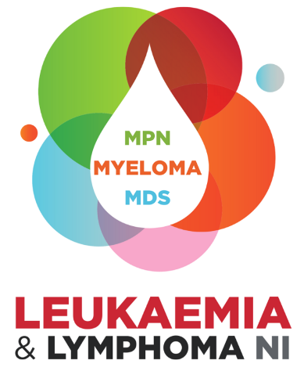

PPIE Fund
Application Form

Aim of PPIE Fund:
We want to encourage researchers to engage with people with lived experience during the design and development stage of their research. We hope this will result in better quality and more relevant research, leading to improved health outcomes for blood cancer patients in Northern Ireland.
Maximum Award:
Maximum project budget of £750 with an understanding that money can only be claimed once expenses actually incurred. E.g. participants may wish to volunteer their time and if so, LLNI would not release the agreed funds within the bid for this/these participants.
Eligibility Criteria:
- Applicants must be currently employed within an academic research institution or within a haematology diagnostic laboratory in Northern Ireland to apply.
- Applicants must be planning to seek funding for a research project which has the potential to have a positive impact on blood cancer patients in Northern Ireland.
Guidance notes:
Question 2 – Please provide a breakdown of the individual costs and total amount requested. To encourage reward and recognition for patient & family involvement, the following costs are eligible:
- Travel & parking costs, refreshment costs and room hire
- Time commitment (either payment or the purchase of gift vouchers) As a guide, we fund £13.80 per hour for feedback on a document and £27.50 per hour when engaging in a focus group
- Partnering with cancer support charity to provide individual counselling support for patients impacted by the emotional toll of sharing their experiences as part of the engagement
Question 3 – Please outline clearly the plan to hold in person events, online engagement or written/verbal feedback to documents and how you plan to connect with patients & families
Max Word Count 100
Question 4 – Please explain why you wish to engage with patients during the design/development of your research project and explain how this would benefit local blood cancer patient Max Word Count 150
Assessment process:
- All applications should be emailed to info@llni.co.uk and can be submitted at any time.
- Applications will be assessed by a member of our research community.
- Shortlisted applications will be considered at following full board meeting.
- Applicants should expect a decision within 8 weeks.
- All applicants will be advised of the outcome of their application via email.
Please Note:
- All information supplied in this application is treated in confidence. The information is furnished to Leukaemia & Lymphoma NI with the understanding that it shall be used or disclosed for evaluation, reference and reporting purposes. If your application is not successful, this form will be destroyed after the retention period deemed as appropriate by the Scientific and Medical Advisory Panel.
- Applicants should be aware that if they receive LLNI funding and then fail to attend the stated event any funding received must be repaid to LLNI by the applicant.
- Successful applicants will be required to provide either a written report or deliver a presentation to the Leukaemia & Lymphoma NI Board of Directors.
LEUKAEMIA & LYMPHOMA NI
Application for PPIE Fund

- Applicant

Name: | Title:
Contact Details:

Telephone: | Email:
Academic qualifications:

Current Position & Band:

Current Institution or Laboratory:

- Amount requested:

- Planned engagement activities:

- Would you like to connect with our LLNI Lived Experience Research Group? Yes/No

- Aims of your proposed engagement:

- Signatures:

- Applicant

I declare that the information provided is true and accurate. If the application is successful, I agree to abide by the Award Conditions of the Leukaemia & Lymphoma NI.

Signature: | Date:

- PI/Supervisors Name

Signature: | Date:

