Leukaemia & Lymphoma NI
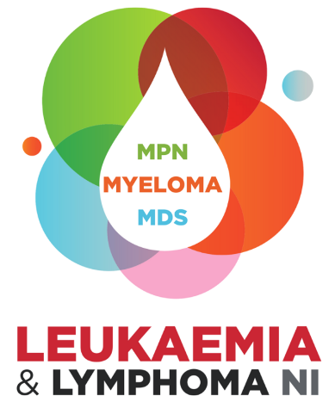

Education Fund 2026
Application Form

Eligibility and Guidance

Aim of Education Fund:
We want to enable diagnostic staff working in haematology laboratories to attend relevant conferences and events, to learn from colleagues in other parts of the UK and Ireland and make connections to enable shared learning and collaboration. We hope this will result in more skilled and knowledgeable diagnostic staff in Northern Ireland, improving the quality and ranges of diagnostic testing for patients with suspected blood cancer.
Eligibility Criteria:
- Applicants must be currently employed in a haematology diagnostic laboratory in Northern Ireland to apply.
- Applicants must seek a Clinical Collaborator for the project, working within the trust in which they are employed
- All applicants must ensure their proposed project within their MSc course will have a sole focus of haematological diagnostics
Maximum Award:
£4000 contribution towards the fees of the 2-year Master’s project. Wherever possible the funds will be paid directly to the academic institution. In exceptional circumstances payment can be made direct to application on production of a fee invoice and evidence of the money being paid to the institution.
Guidance notes:
Question 2 – Please include the name of the course, institution and a short list of the modules of you wish to undertake Max word count 100
Question 3 – Please give both start and end dates for the course being applied for
Question 4 – Please use this section only to outline the project plan for haematological diagnosis, as appendices or covering letters cannot be used to assess your application Max 2 A4 pages
Question 5 – Please use layman’s terms to outline the potential for this project to improve the outcomes for patients with blood cancers to allow the charity to promote the difference our research investment has made. We will also use this statement to promote the project if your application is successful. Max Word Count 150
Assessment process:
- Completed applications should be emailed to info@llni.co.uk before Friday 1st May at 12noon
- Applications will be assessed by two members of our Scientific and Medical Advisory Board
- Shortlisted applications will be considered at our June board meeting, after which all applicants will be advised of the outcome of their application via email.
Please Note:
- All information supplied in this application is treated in confidence. The information is furnished to Leukaemia & Lymphoma NI with the understanding that it shall be used or disclosed for evaluation, reference and reporting purposes. If your application is not successful, this form will be destroyed after the retention period deemed as appropriate by the Scientific and Medical Advisory Panel.
- Applicants should be aware that if they receive LLNI funding and then fail to complete the project/qualification any funding received must be repaid to LLNI by the applicant.
- Successful applicants will be required to provide a either a written report or deliver a presentation to the Leukaemia & Lymphoma NI Board of Directors.

LEUKAEMIA & LYMPHOMA NI
Application for Education Fund

- Applicant

Name: | Title:
Contact Details:

Telephone: | Email:
Academic qualifications:

Current Position:

Current Location:

Previous positions:

- Master’s Course Applied For:
Please detail the course and institution where the masters will be completed.

- Dates of Course:

- Details of Masters Project to be undertaken:
Please provide details of the project to be completed as part of the masters

- Layman’s explanation of potential impact on blood cancer diagnosis:
Please provide a short layman’s explanation about how the project aims to have a positive impact on the diagnosis of blood caners in your lab.

- Clinical Collaborator

Name: | Title:
Contact Details:
Telephone: | Email:
Academic qualifications:

Current Position:

Previous positions:

Short statement on the clinical relevance of the proposed project:

- Signatures

- Applicant

I declare that the information provided is true and accurate. If the application is successful, I agree to abide by the Award Conditions of the Leukaemia & Lymphoma NI.

Signature: | Date:

- Clinical Collaborator

Signature: | Date:

Please submit completed and signed applications to info@llni.co.uk for the attention for the Chair of the Scientific & Medical Advisory Panel by Friday 1st May at 12noon.

